
MARKS CERTIFICATE
SEAT NO:
GROUP: SCIENCE
DISTRICT: GHOTKI
ELEMENTARY SCHOOL CERTIFICATE ANNUAL EXAMINATION MARCH 2026

CERTIFICATE SHOWING THE NUMBER OF MARKS IN ACCADMIC AND NON-ACCADMIC SECURED BY THE BELOW NAMED CANDIDATE
NAME:

FATHER’S NAME:

SURNAME: CLASS:

SUBJECTS | MAX.MARKS | MIN. MARKS | OBT.MARKS
English | 100 | 33
Mathematics | 100 | 33
G.Science | 100 | 33
Urdu | 100 | 33
Sindhi | 100 | 33
Islamiat | 100 | 33
S. studies | 100 | 33
NON-PAPER PERFORMANCE
Oral | 100 | 33
Attendance | 20 | 5
Discipline | 20 | 5
Class Performance | 10 | 3
Writing | 10 | 3
Complete Copies | 20 | 5
Extra Activities | 20 | 5
TOTAL MARKS |  | .. | Total Obt marks:
MARKS IN WORDS |  |  | Rank:

GRADE:
PERSENTAGE:
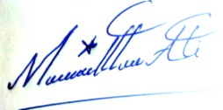
ISSUANCE DATE:05/01/2026
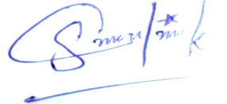
SIGNATURE
CLASS TEACHER SIGNATURE CONTROLLER OF EXAMINATIONS

